Word Roll

Roll 1 →  Roll 2 ↓ | 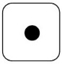 | 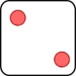 | 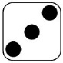 | 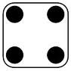 | 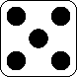 | 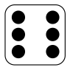
 | head | back | knee | finger | leg | hip
 | teeth | tongue | stomach | ankle | toes | toe
 | neck | hand | feet | wrist | thigh | chin
 | cheek | belly | shin | elbow | arm | heel
 | throat | nose | shoulder | tooth | armpit | lip
 | chest | ear | eye | mouth | eyes | forehead

